LAST
HASH
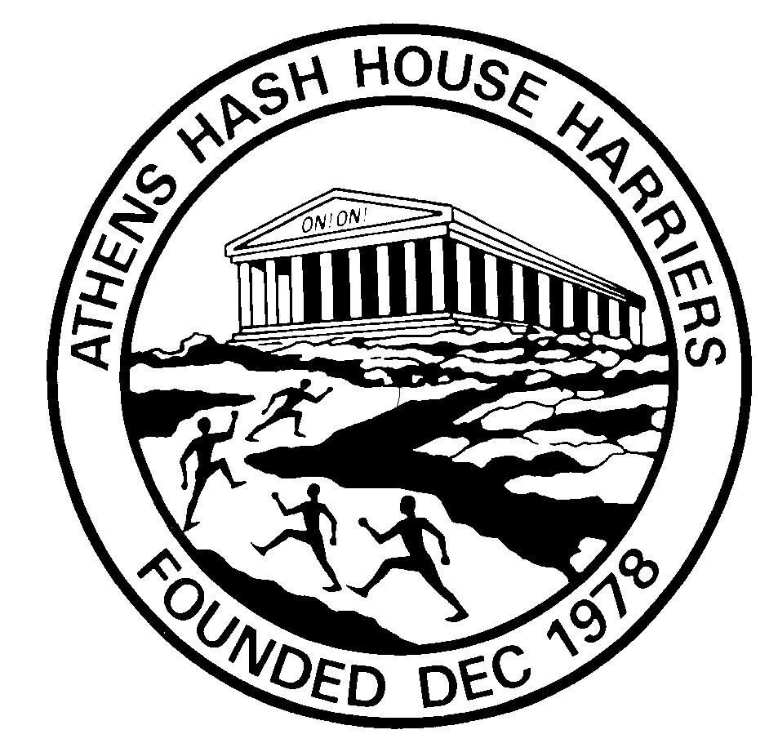

Hash_Name
Run # 1xxx nn^{rd} NNNN 200n

The Athens Hash House Harriers



Whose loyal and outstanding service to hashing, is hereby recorded for posterity in the annals of The Athens Hash House Harriers has amassed more than nn runs and laid nn trails with us and in doing so has sometimes foregone the pleasures of loved ones and pastimes, nobly surrendered all hope of career advancement in order to participate in weekends and weekly hashes during summer and winter alike. He has jogged, walked, staggered and on rare occasions even run, an indeterminate number of kilometres up and down, checking there and checking back, through mud, nettles, dung, ice, snow and rivers to reach beer stops and ON-IN’s and sometimes afterwards as a miscreant participating in Down-Downs for deeds perpetrated during and after the runs such as the wearing of new shoes or poser running gear, taking short cuts especially to avoid shiggy and getting wet feet, calling ON-ON at the wrong times, running at the front (?), falling asleep in car parks, not even finding the start point – and other such heinous crimes committed, as determined and promulgated by the Religious Advisor, sanctioned by the Joint-Masters,
and witnessed by the Circle :-

Is a Hasher of True Distinction!

JM : Mad Dog
OS : Clitoria
JM : Strawberry Foreskin

HC : Camel Toe.
RA : Playboy 2
HH : Pop Up
HCo : Mountain Goat
TM : Cocks-n-Balls.
VQ : Shiva

